TABLE OF CONTENTS

Acknowledgementi

Abstract4

List Of Figures3

Chapter 1 Introduction5

Chapter 2 Problem Statement6

Chapter 3 Solution7

Chapter 4 Levels of Users8

Chapter 5 Normal User9

Resource Book9

Resource Availability10

Resource Search11

Chapter 6 Admin User13

Authentication and Authorization13

Request Approval13

Classroom /Lecture Entry15

Chapter 7 Master Admin User16

Authorized User16

Room Type18

Building19

Rooms20

AddRooms21

Forgot Password22

Sending Mail24

Chapter 8 Design25

Database Design25

Page Design25

Chapter 9 Conclusions26

Chapter 10 Future Works27

References28

**LIST OF FIGURES AND TABLES**

1. **Snippet Resource Book(days) ………………………………….……………..9**
2. **Snippet Resource Book(Availability) ……………………………….….…..10**
3. **Snippet Resource Book(Availability) ……………………………….….…..10**
4. **Resource Book ………………………………………………………....….…11**
5. **Snippet Resource Search……...………………………………………......….12**
6. **Resource Search………..……...……………………………………….....…..12**
7. **Login Page .…………………………………………………………….……..13**
8. **Snippet Resource Approval..…………………………………………..…….14**
9. **Resource Approval .………………………………………………………….14**
10. **Snippet Resource Book(days)………………………………….…………….15**
11. **Lecture Entry…………..…...………………………………………………...15**
12. **Snippet Authorised User… ………………………………………………….16**
13. **Snippet Authorised User(btnupdate)……….……………………………….16**
14. **Authorised User ………….…………………………………………………..17**
15. **Authorised User(Updated)………………………….…………………….....17**
16. **Snippet Room_Type ………….……………………………………………...18**
17. **Room_Type ………..………….……………………………………………...18**
18. **Snippet Building…………...…………………………………………………19**
19. **Building…………...…………………………………………………………..19**
20. **Snippet Rooms...…………...…………………………………………………20**
21. **Rooms………...….………...…………………………………………………20**
22. **Rooms(Updated)…………...…………………………………………………21**
23. **Snippet AddRooms….…….………………………………………………….21**
24. **AddRooms…………...…….………………………………………………….22**
25. **AddRooms(User Pop up)....………………………………………………….22**
26. **Snippet Forgot_Password...………………………………………………….23**
27. **Forgot_Password………....………………………………………………….23**
28. **Snippet Sending Mails …….………………………………………………...24**
29. **BootStrap (Modal Popup User).……………………………………………25**

**ABSTRACT**

We have created an ASP.NET website. Alongside the ASP.NET We have used ADO.NET, and C# as the main language. The website is to overcome the few of the issues for managing the available resources within the college campus i.e. Seminar halls, Conference Rooms, Classrooms, Laboratories etc. The managing basically means having that specific resource registered and retrieved through the provided interface. So the website lets the user input the required conditions either may be for registering the resource for any pre-planned workshop or Expert Talk and many more. The website also lets the user retrieve and check the availability of the desired resource may be while registering itself and also according to a timespan of the user input dates. The website lets the authorized user to check all the requests and approve them as per the requirements and the authorized user is also notified by the mail while registering. The requested user is also notified by the mail of approval. There is also a provision for entering the classroom schedule according to the timetable by the authorized user for the convenience of the end user to receive the proper details of the classroom lectures too and also for avoiding the clashes during any Expert sessions, if any. So, ultimately the website includes almost all the functionalities for managing the resource which was manually handled previously.

1. **INTRODUCTION**

**Purpose: -**

To manage the resource according to the need basis. Managing resource may include requesting for the available resources, approving and rejecting the requests, adding resources, managing the resources, managing the users etc.

**Reason: -**

Because till present date all the task of managing the resources was done manually. So to reduce all this manual processes and having a centralised system for managing the resource was very much important.

**Work: -**

For any institutes many sessions like Expert talks, or Workshops etc. are ongoing. So it is very much important for them to manage the resources accordingly. Not only managing but making proper utilization of the resources is also too much important. The situation that may arise here may be like:

* Resource may be pre-booked.
* Resource may be occupied for routines.
* Resource may be registered by some other departments, etc.

This may sometimes lead to any clash like situations etc. So in order to avoid these kind of situations we can have a centralized application which can manage all the resources and all such situations.

Thus a centralized application keeping in mind the present scenario can be developed. Which reduces the complexities, makes it easier and manages the resource in a well-organized manner.

1. **PROBLEM STATEMENT**

Whenever we are supposed to conduct a workshop, or expert session, or meeting in the campus then it was very much a hard situation due to following reasons:

* You may have to call the person in-charge.
* You were supposed to write mail in order to notify the person about your requirements and request.
* The records maintained were manual.
* Not only that almost all the procedures included have to be performed manually.
* So maintaining the record was difficult. Any change in the event needs to be modified and again seek the permission of the user. And updating the details in the record of person in-charge was also to be manually be made.

1. **SOLUTION**

We can create a centralized application. Now this application can provide us with the major functionalities including almost all that are manually done till date. The functionalities can be extended as per the requirements too. Through this application almost all the tasks can be made computerized.

We have to create the application which maintains the data entries for the requests. The requests are displayed to the Admin user. Then he will grant or reject the request. Now, till date for all these process mails were transferred and the user may be contacted by some other means. But in our application we decided to use the mails that are written through the program itself.

These mails are sent for the request to the Admin user and for the grant or reject to the user who made the request.

Through this application many clashes for any resources, like for the workshop or for the others can be avoided, due to the pre-planning. Through this application the Admin user can have an watchful eye on the resources.

1. **Levels of Users**

For this centralized application we have various 3 levels of users. They are as listed below:

a.) Normal User

b.) Admin User

c.) Master Admin User

Here is the brief roles and rights assigned to these users as below:

1. Normal User:

The normal user is the one who can make requests for the resource. They can check the availability of the resource, whilst making the request. They can check the occupancy of any particular resource. They can search for the entire occupancy in any user specified range of days. The normal user does not have any login id or anything else unlike the other two users.

1. Admin User:

The Admin users are the assigned with the task of eyeing and approving the request made by normal users. They are supposed to make the data entry of the regular lecture/classroom schedules. They can also perform every single task performed by normal user. But the scenario here is they are not supposed to request to anyone else.

1. Master Admin User:

The users are at top level of the hierarchy. The y are the ones who have the rights to manage the resources. Managing here means adding, updating and deleting the resources. They also manage the authorised users i.e. adding, updating or deleting users. One of the other important responsibility of this user is to manage all these roles of the existing users i.e. he can assign or update the roles of the users.

**5.NORMAL USER**

* **Resource Book:**

This is the basic web form which takes the input from the end user for registering the resource for future purposes like Workshops, Expert Talks etc. The user inputs the required details and then requests for checking the availability. So he gets the output in terms of whether the specific resource is allocated or is available in that particular mentioned conditions including the dates and the time slots. The main advantage here is as soon as the user request the available resource the authorised user is notified about the request through an email which makes keeping the track records very much easier.

So, here we have designed the efficient query for processing the user request. The request processing mainly includes retrieving the data from the database table and comparing the user request with the previously made requests made by other users for the same resource. Now we do have a scenario where the resource may be occupied for some regular routine lectures or something. These routines are defined in terms of days i.e. Mon, Wed, Thu etc. in a specific time period. So I was to add the ‘days’ column in database table for the same. Now here comparing dates was particularly something easier. But to work with comparing days which was added later on as I came to know about the situation was a bit trickier. So I used something like ‘Pattern’ with the ‘like’ clause for retrieving and comparing with the allocated database entries.

We are planning to add some proper AJAX into the web form as per the requirements. The ADO.NET architecture I used here for processing the database table is ‘Disconnected’ architecture which includes DataSet and a few more.

**Code Snippets:**

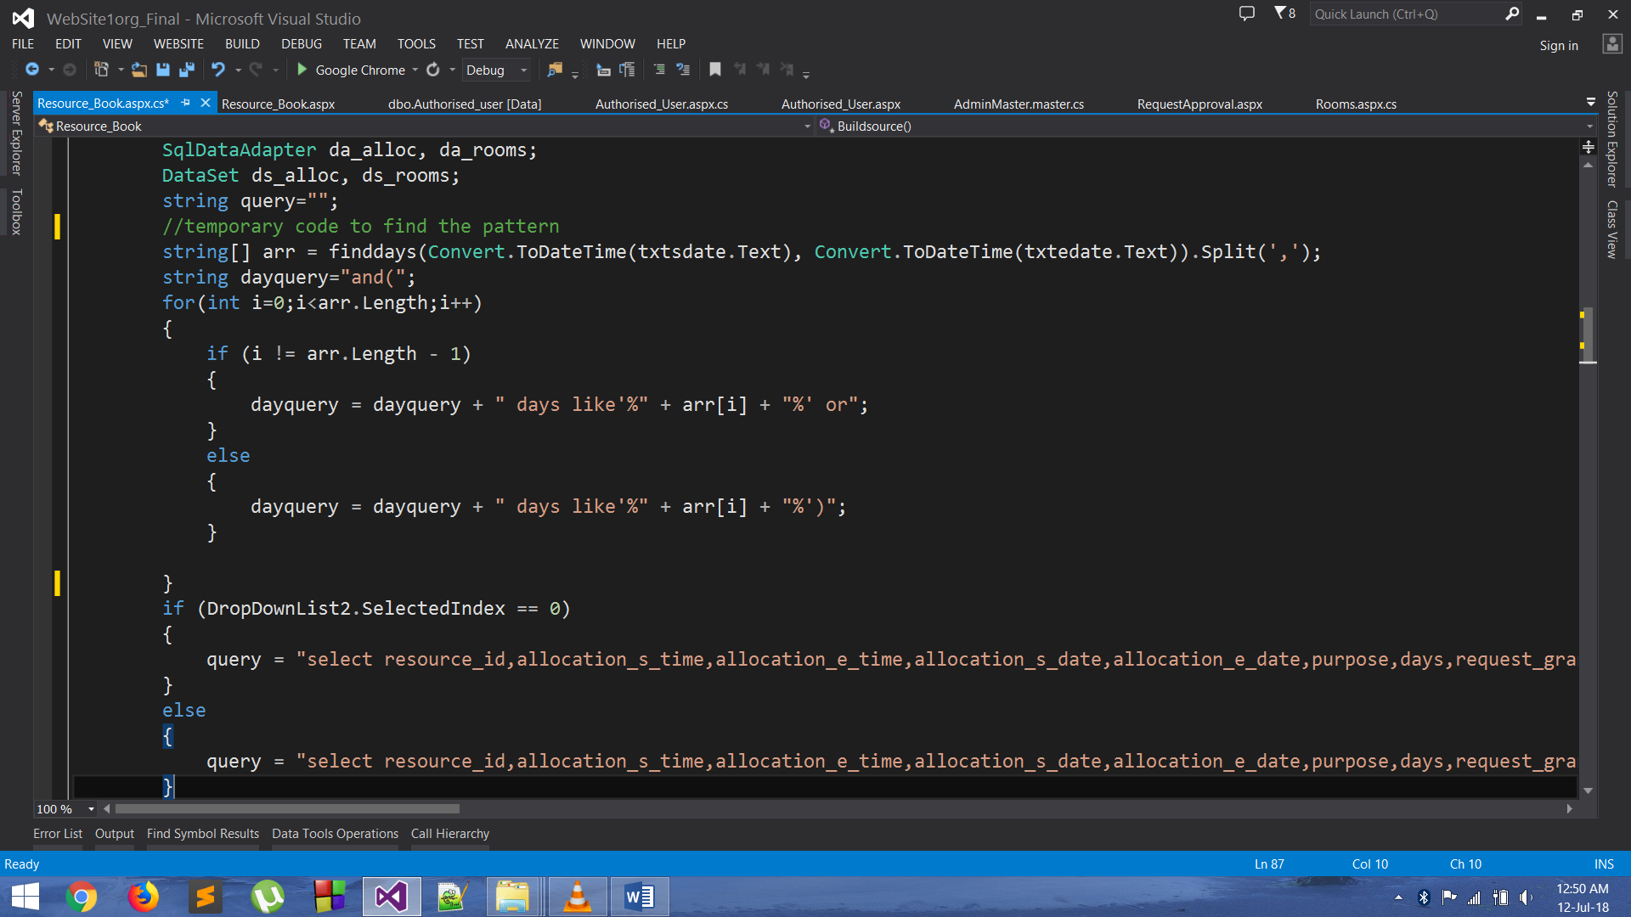

Figure 1 | Snippet Resource Book (days)

* **Resource Availability:**

Here I have created the efficient query for retrieving the requested resource from our database table. After retrieving the data and taking the input from the user I had to display the output in terms of whether the resource is available or not. If the resource was not available then I had to mention the reasons for that which includes displaying the details for the resource i.e. Start to End Date, Start to End time, Purpose, Contact Person, etc. Here in checking the availability also, it was very much important to go through comparing the ‘days’ along with the dates and times. Displaying the data makes it easier for the user to contact the Contact person who has made the request prior to him and discuss and sort out the things to avoid any further clashes amongst their works.

**Code Snippets**:

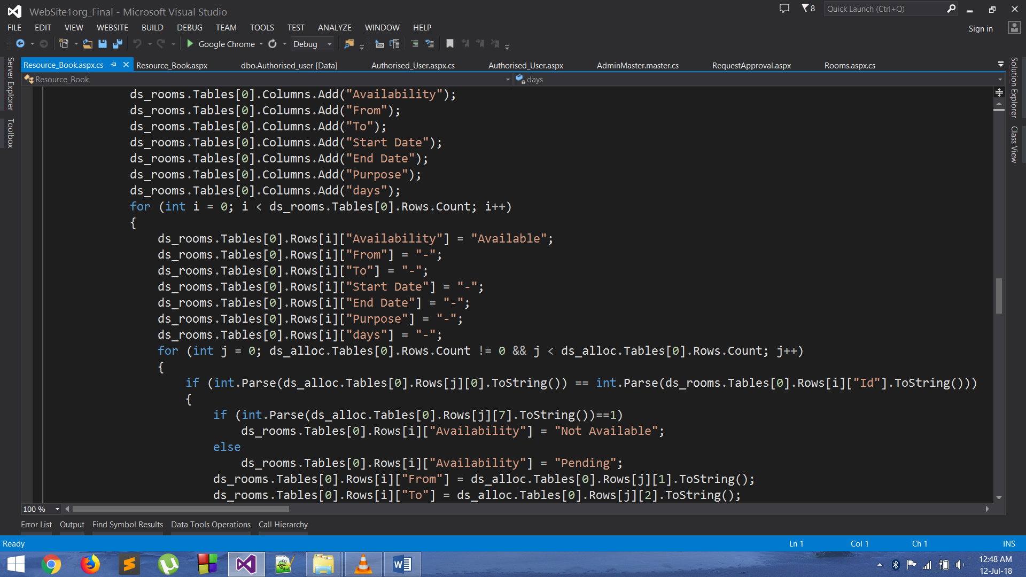

Figure 2 | Snippet Resource Book (Availability)

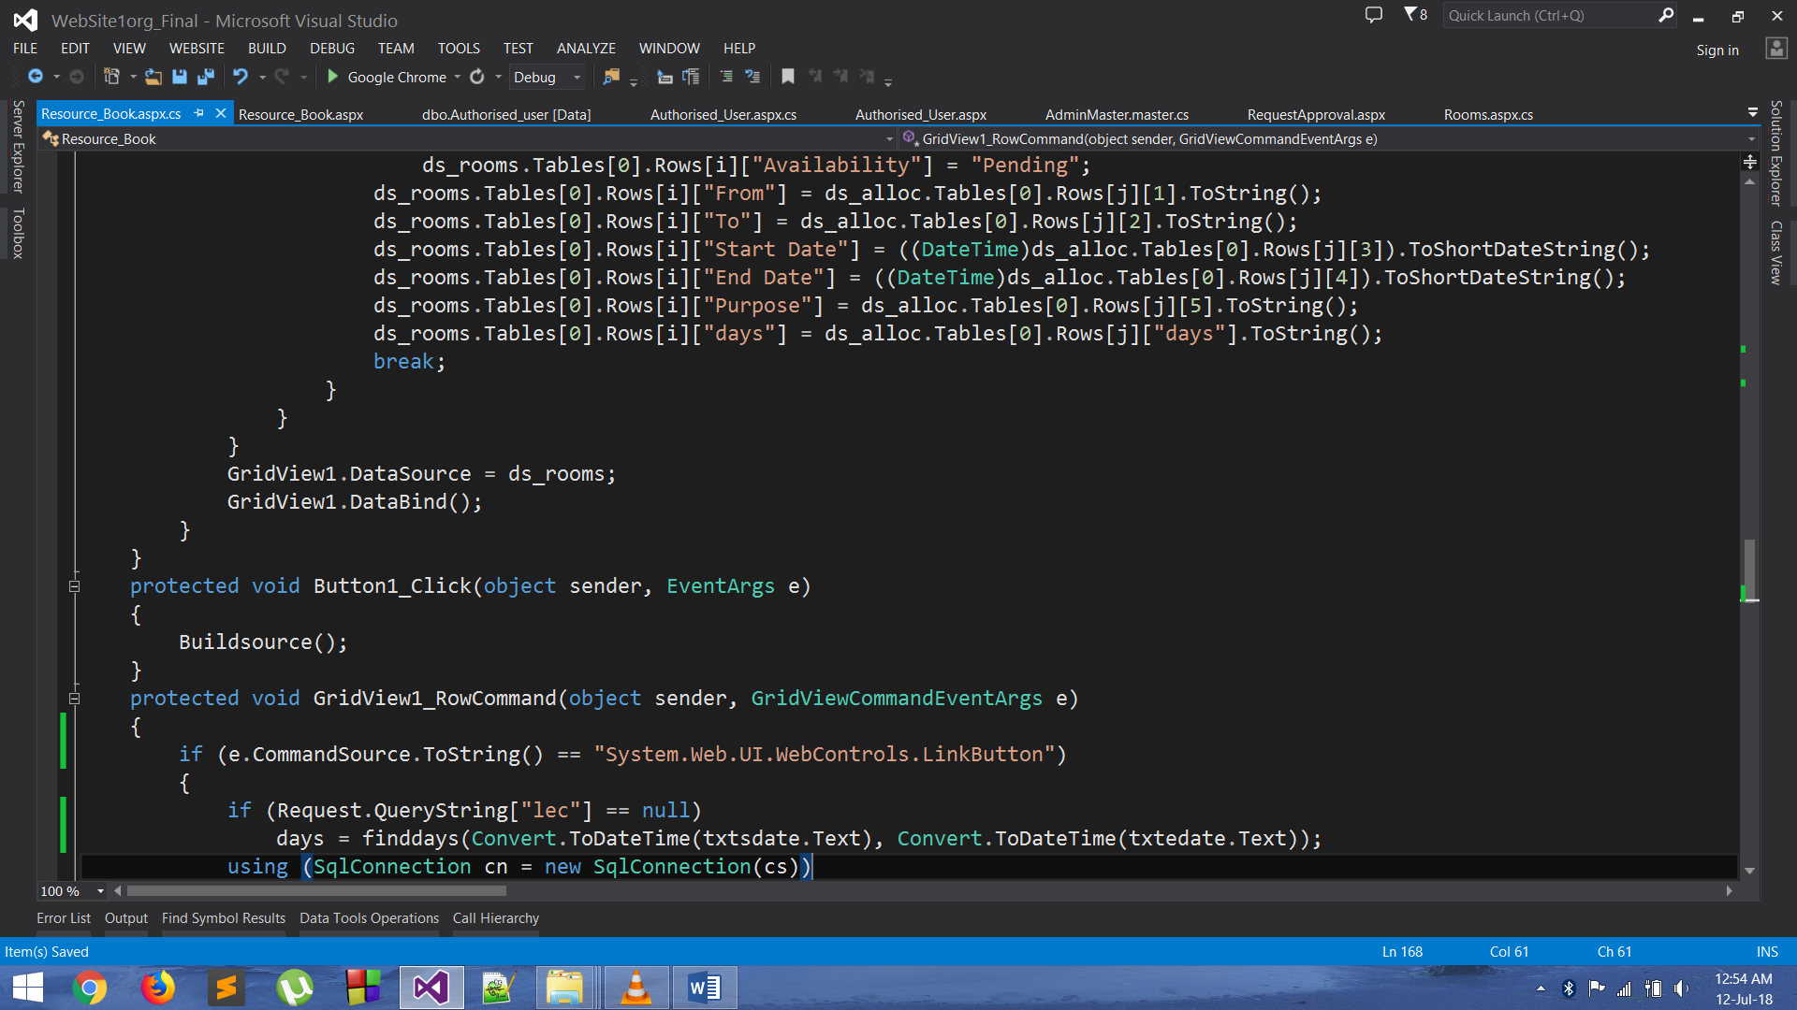

Figure 3 | Snippet Resource Book (Availability)

**Snap shot:**

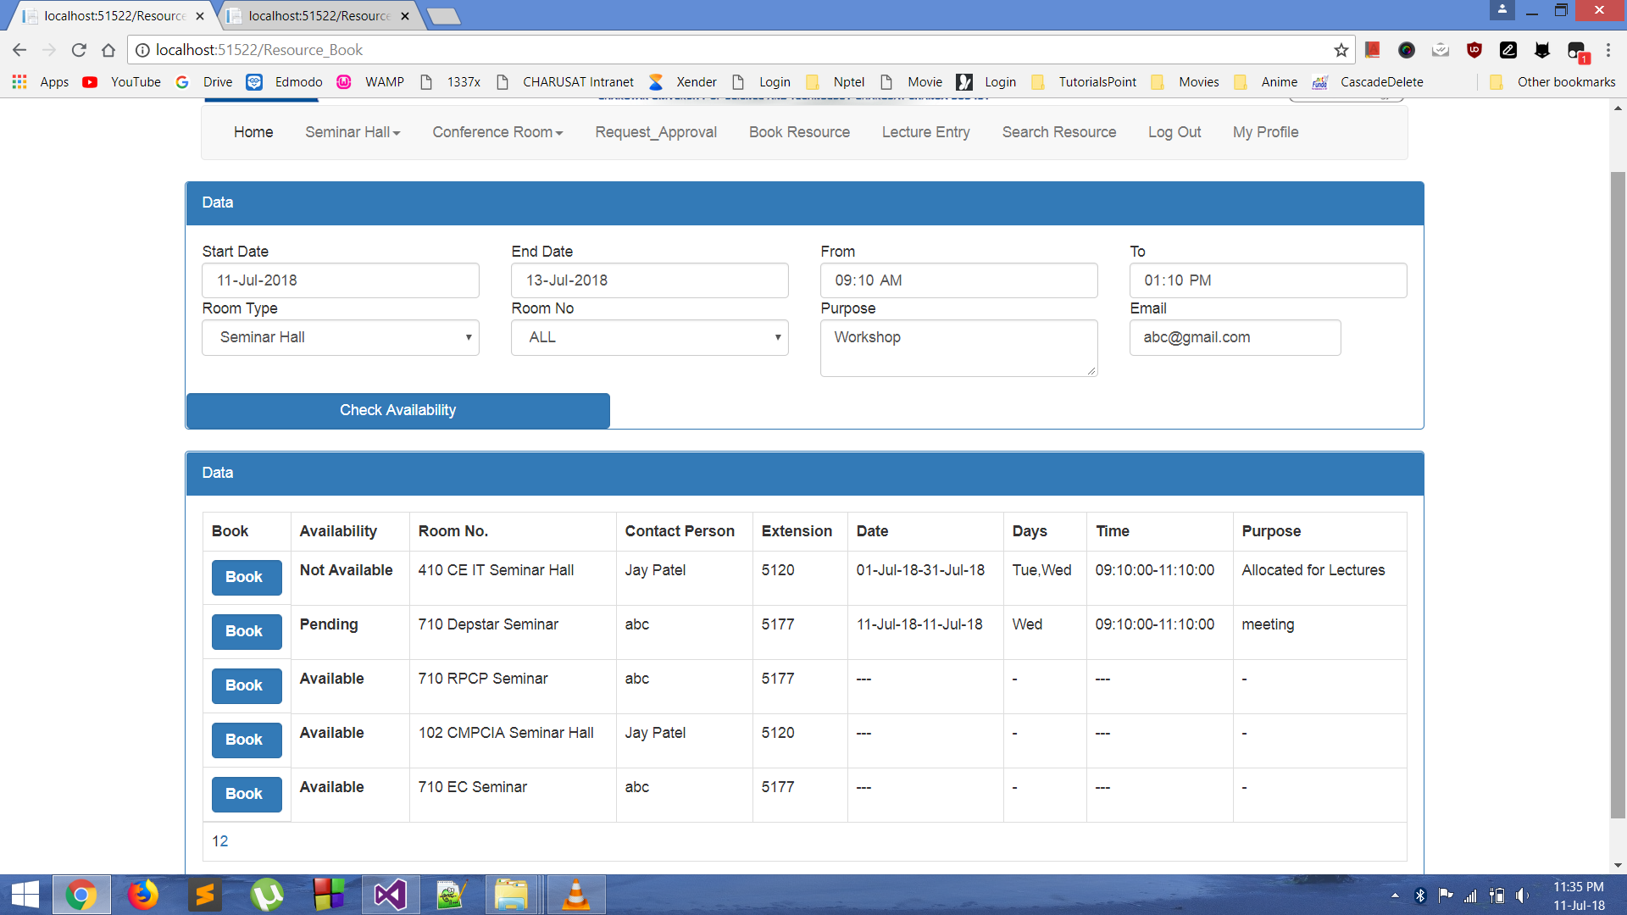

Figure 4 | Resource Book

* **Resource Search:**

Whenever the user wants to check the overall occupancy of the particular resource in an entire range of dates and all the time slots he is supposed to look up in this web form. This web form asks the user for the resource name and the range of the dates for which the user wants to check the occupancy. Then in the output the user is served with the occupancy details of all the time slots in that range mentioned along with the details like purpose and time duration etc.

Here the entire range and each and every slot of the day is to be compared with the allocated entries in the database table. So I had to design the efficient query for retrieving the data. After retrieving the data, I was supposed to use the appropriate Data control element for comparing it to the allocated entries.

So here the comparison part is considered to be the life of this web form. Thus, simply comparison itself was not enough, but efficient way of comparing was very much the thing. So here I have used the idea that from which particular index to start till which index from the details of the allocated entries. Here finding this range of index was very much important because by doing so we can avoid the unwanted iterations which don’t even have to be performed because there is no allocation in that particular range of index. After finding these indices comes the part of checking the particular days in that range of allocated dates. Finding these days in that range was the trickiest part. So I used the same thing with dates i.e. finding the index by taking the difference among present day and the day of the allocated date and then incrementing the index in somewhat different manner because as the same schedule is followed up the next week. So if one entire week from range is completed with then the task becomes easier for that range too as it has just to followed up the very similar manner.

**Code Snippets:**

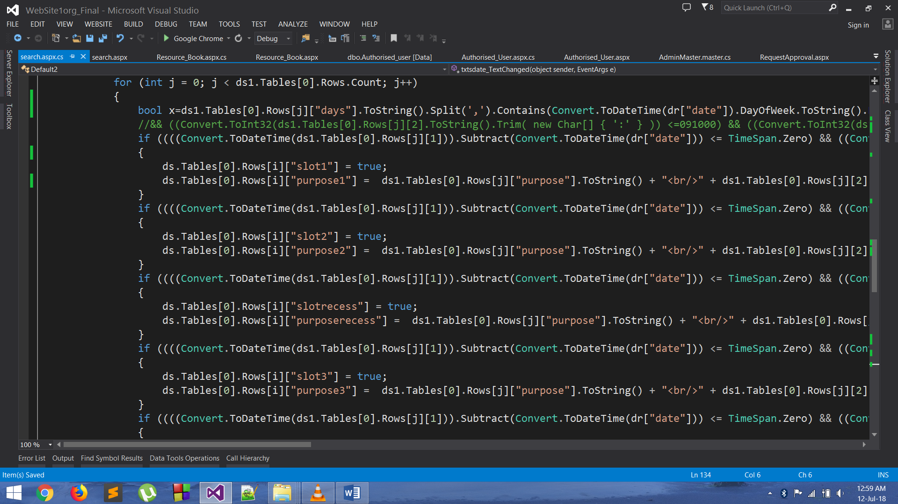

Figure 5 | Snippet Resource Search

**Snap shot:**

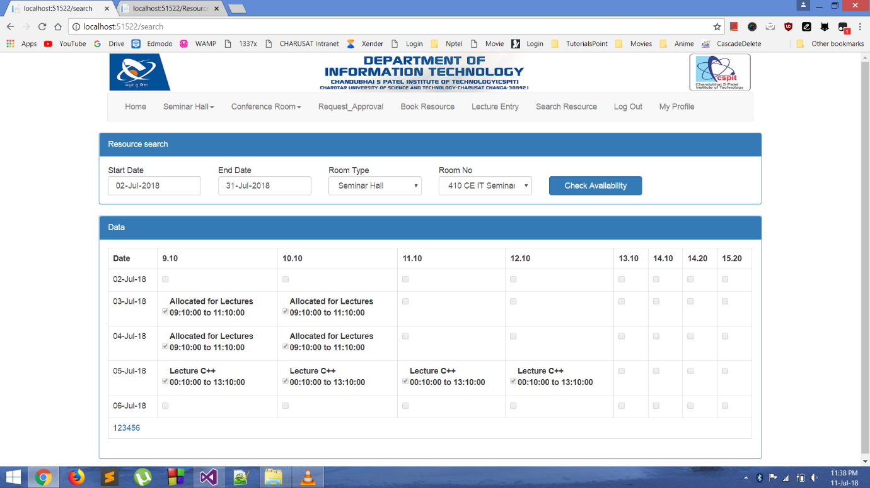

Figure 6 | Resource Search

**6.ADMIN USER**

* **Authentication and authorization:**

There are certain authorised user. So they are supposed to Login and perform their activities. So we have to add the Login web form and add the authentications for logging in the authorised user. Now, after they are logged in they can perform their specific task like approving the requests, classroom/resource entry etc. But here the authorised user is authorised only for certain resource. So whenever the user logins he just should be able to outperform tasks on the resource for which he has the authorization. Thus authorization for this was also added.

**Snap shot:**

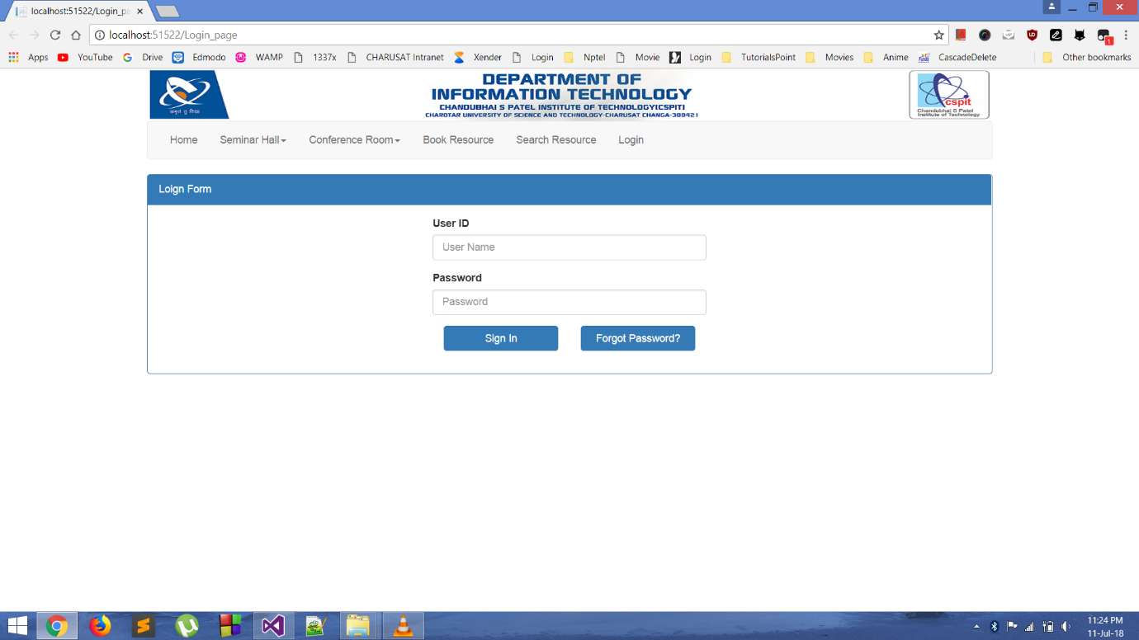

Figure 7 | Login Page

* **Request approval:**

All the request that are made and comes under that authorised user are supposed to be approved. Now after the user logins and selects Request Approval he would be asked to select the particular resource. So the user would be provided with all the requests that are pending to be approved. After going through the details and checking the importance amongst the common entries i.e. for same resource in the same period he will approve the pending request and change the status to granted or not.

Here as soon as the authorised user approves the request the former user who made the request receives the confirmation mail. This confirmation mail includes the details for registering the resource for the given dates. So the former user will come to know as soon as he is granted the permission which is very much helpful.

**Code Snippets:**

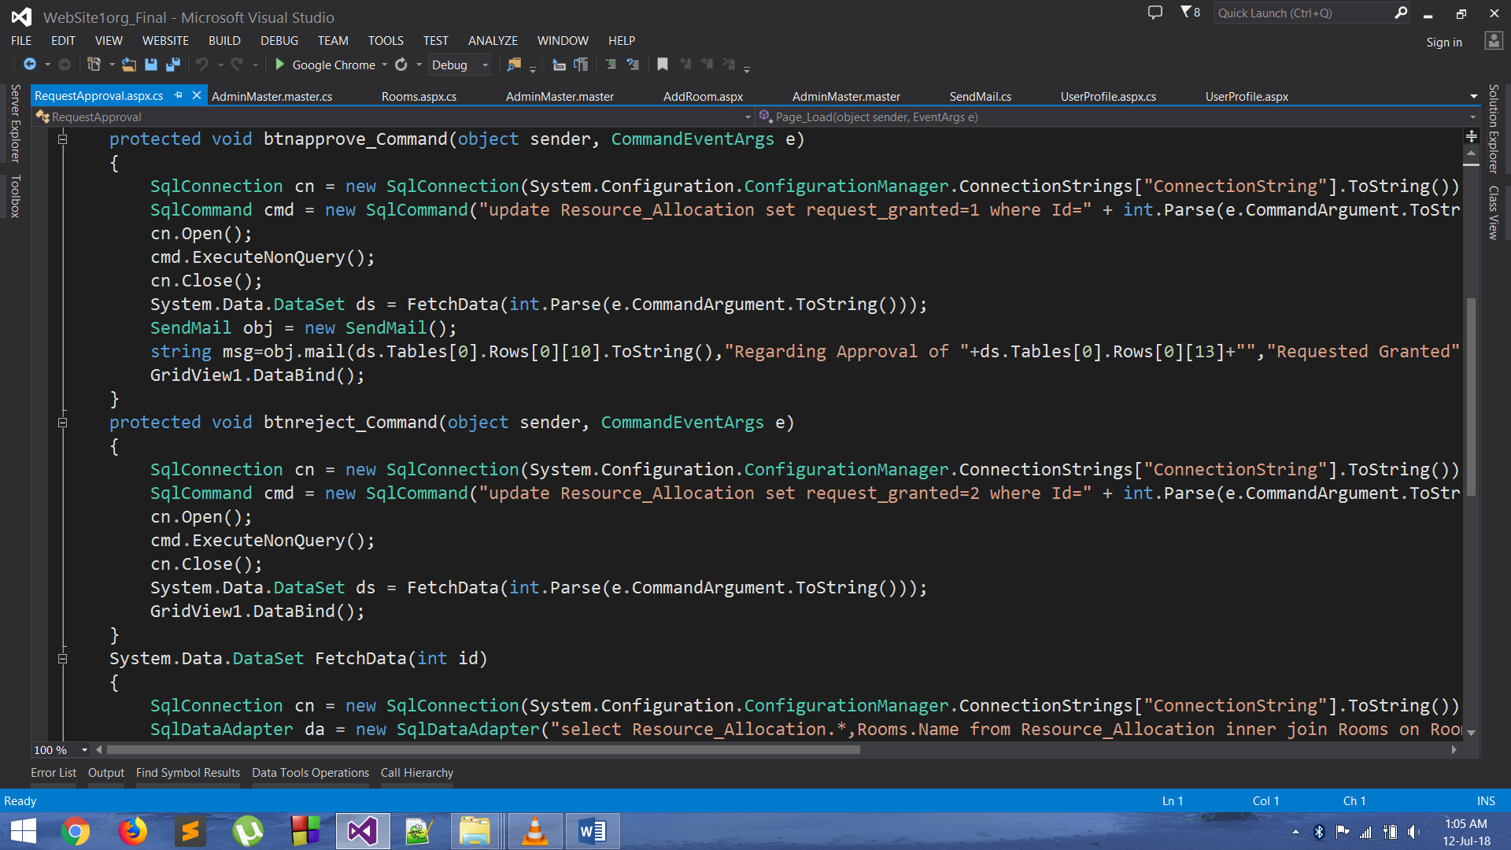

Figure 8 | Snippet Request Approval

**Snap shot:**

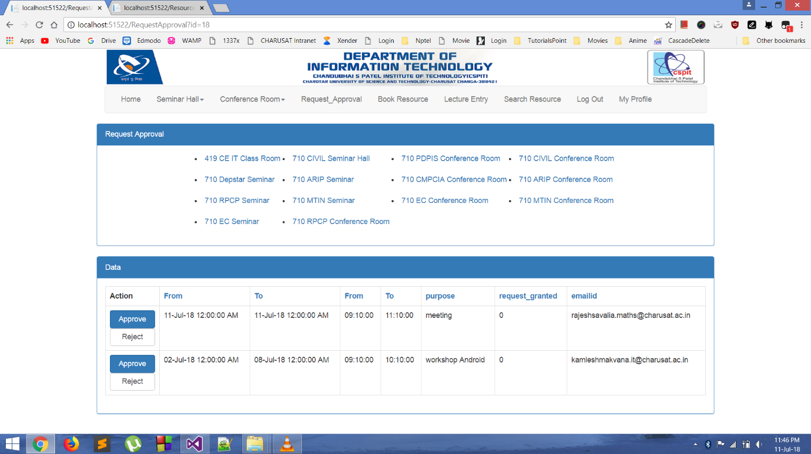

Figure 9 | Request Approval

* **Classroom/Lecture Entry:**

The regular routine classrooms are also to be entered and processed if required. So, I have created another web form for the very same purpose. These are the certain tasks that are to be performed by some of the authorised users only. So, only a person logged in can access this web form. The main idea for classroom entry is for a particular range of date the classroom slots are registered on particular days. So, here the user is provided with the controls to select day for the entry.

**Code Snippets:**

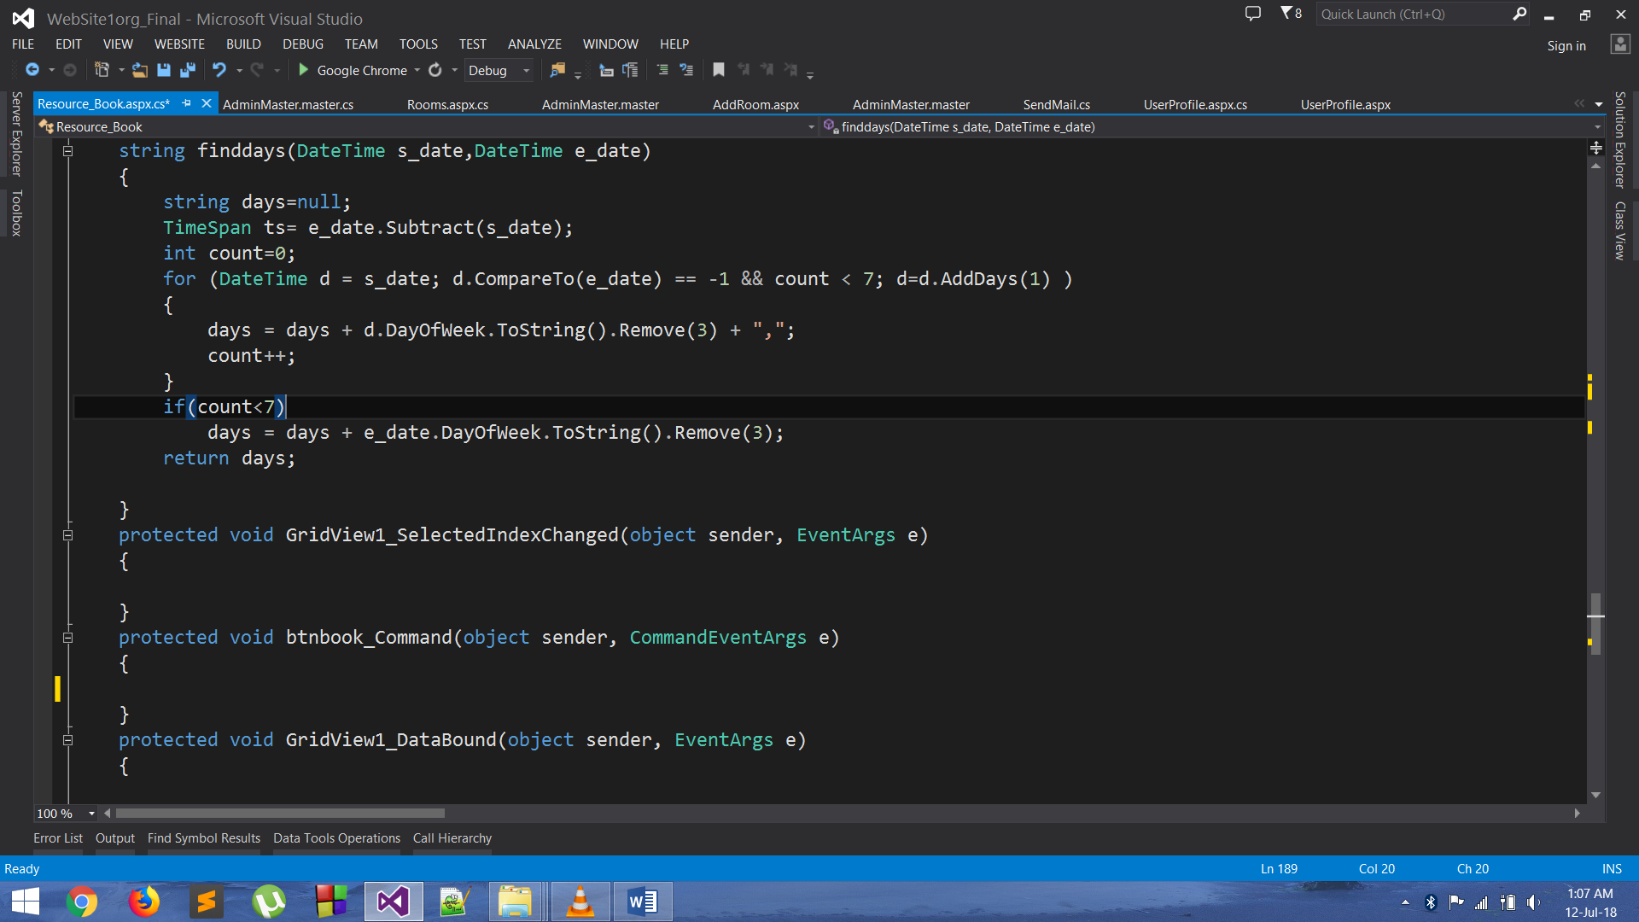

Figure 10 | Snippet Resource Book(days)

**Snap shot:**

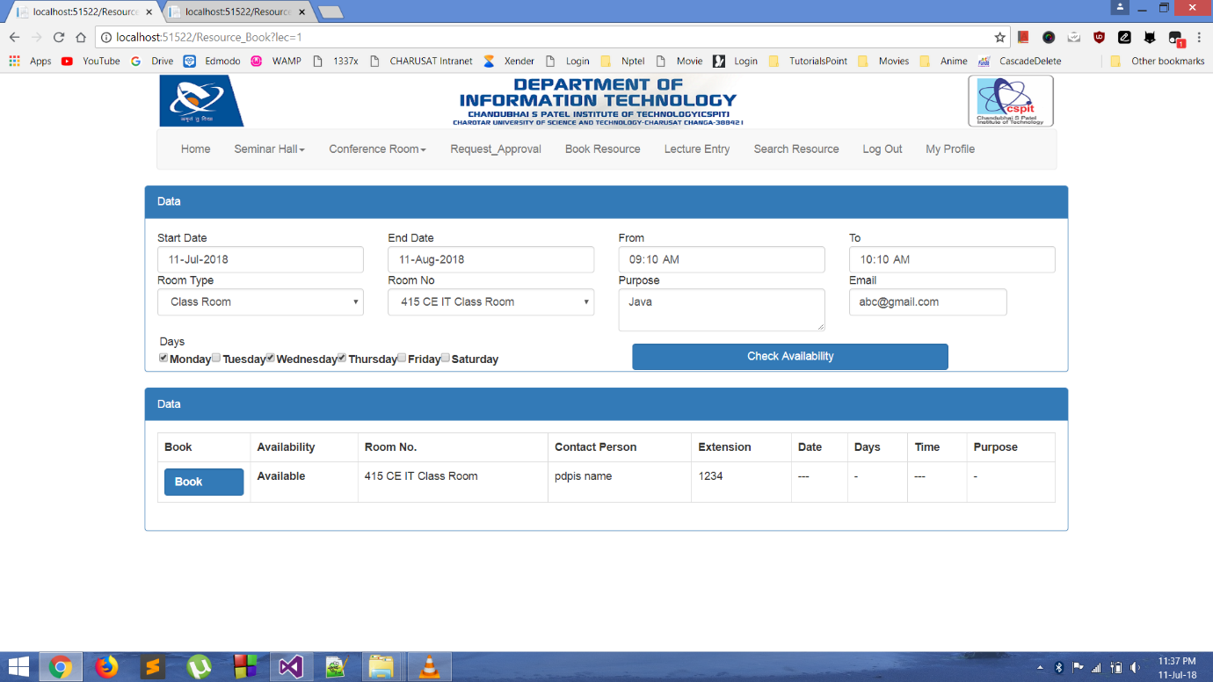

Figure 11 | Lecture Entry

**7.MASTER ADMIN USER**

* **Authorised user:**

For adding the new authorised user the master user just has to login with his credentials and then by simply clicking Add User he can add the authorised user to the database by adding proper details. Simply he can also update the existing details there too. He can also manage the roles to the user here itself only.

**Code Snippet:**

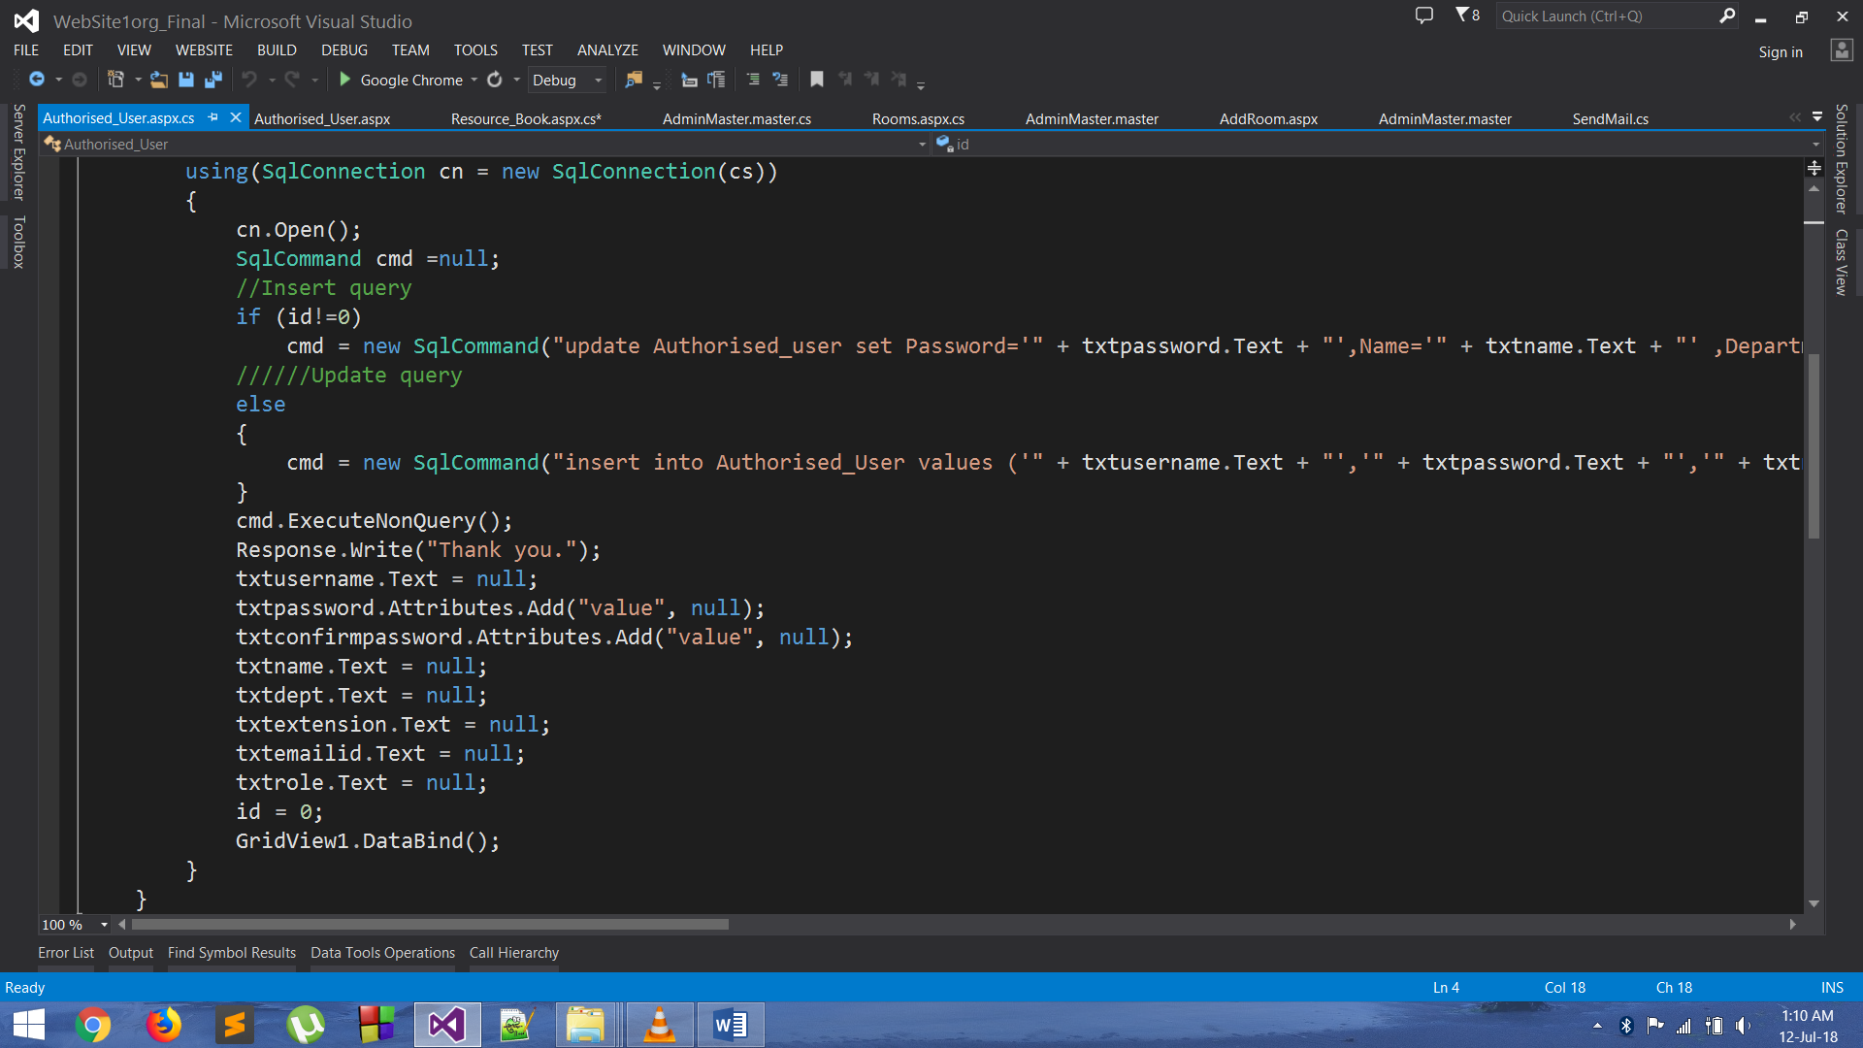

Figure 12 | Snippet Authoorised_User

This snippet here includes the btnsubmit method. This method does the functionality of adding and updating the existing user.

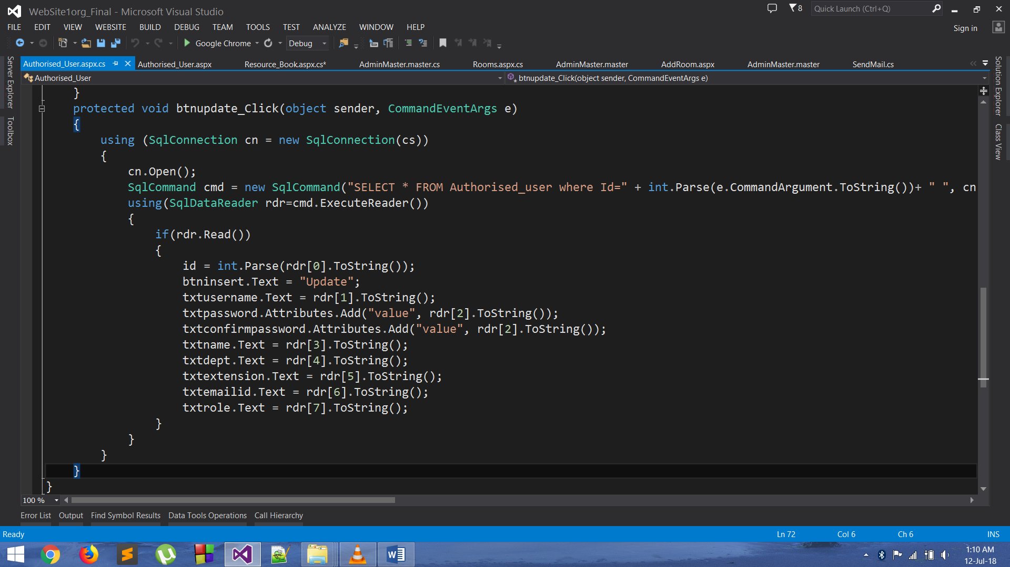

Figure 13 | Snippet Authorised_User(btnupdate)

This snippet here has the btnupdate_Click method this method simply is used to fetch the data from the user selected row and then display the very same data in our form, in order to edit.

**Snap shot:**

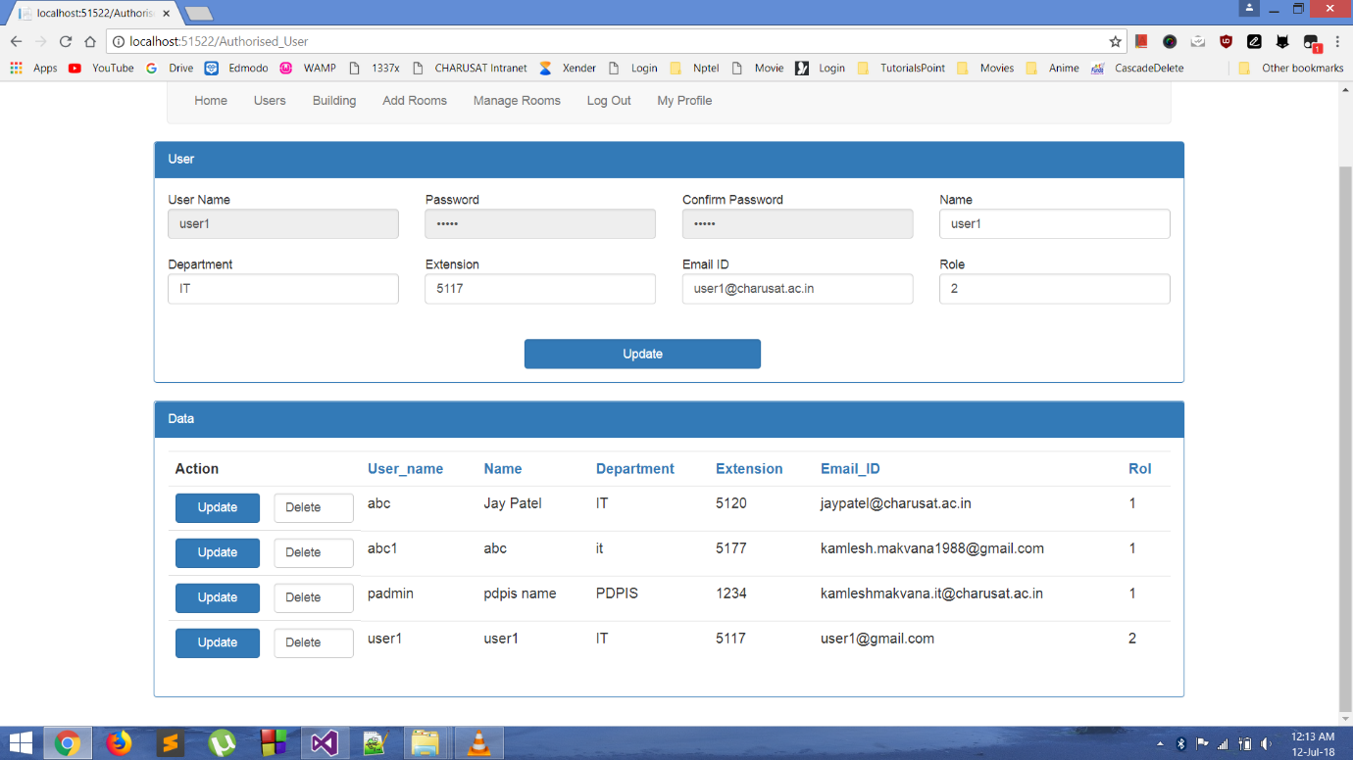

Figure 14 | Authorised User

For updating the data, you just simply have to select the row of the user which you want to modify the data

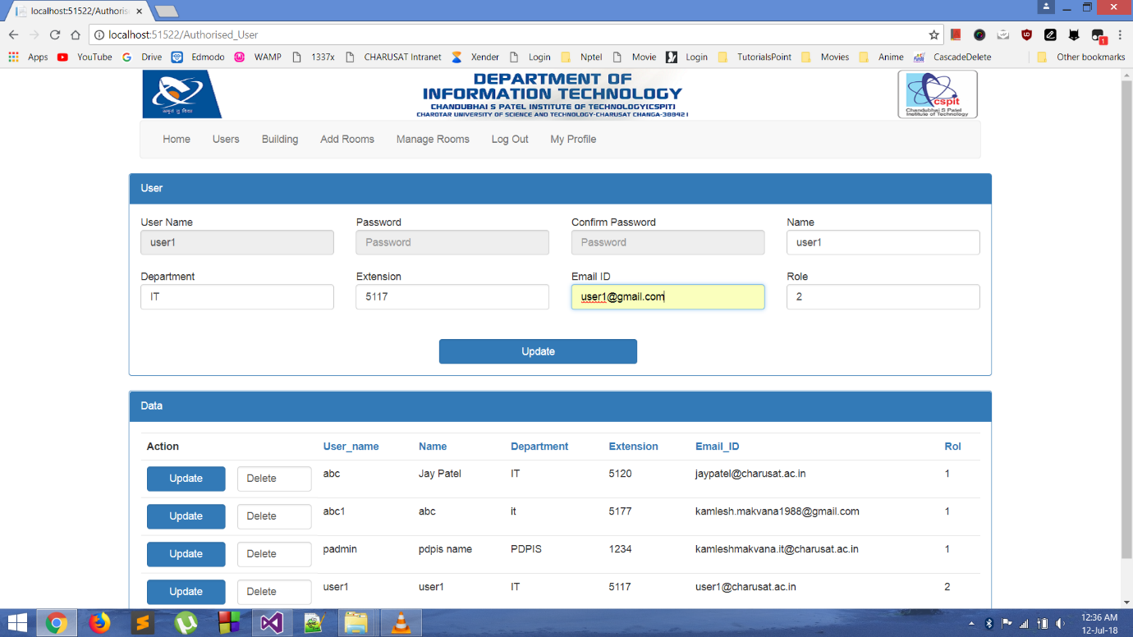

Figure 15 | Authorised User(Updated)

* **Room Type:**

There may arise a situation when we want to add room type. So this task can be performed using this web form available here.

**Code Snippet:**

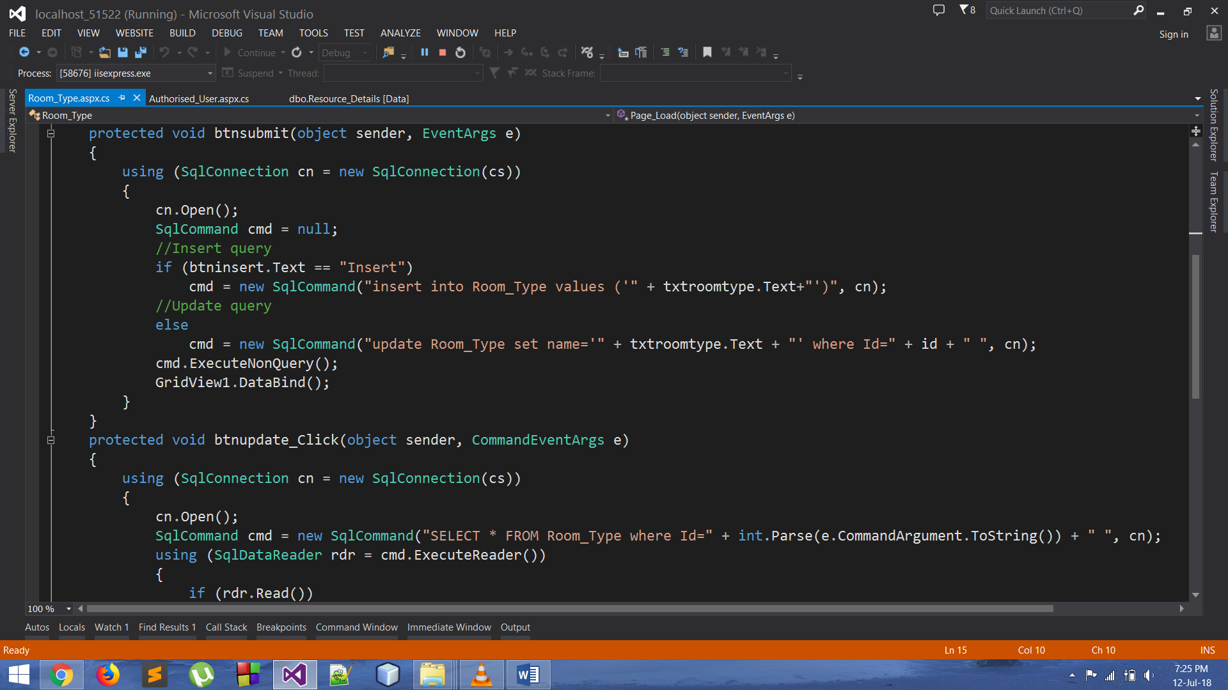

Figure 16 | Snippet Room_Type

**Snap shot:**

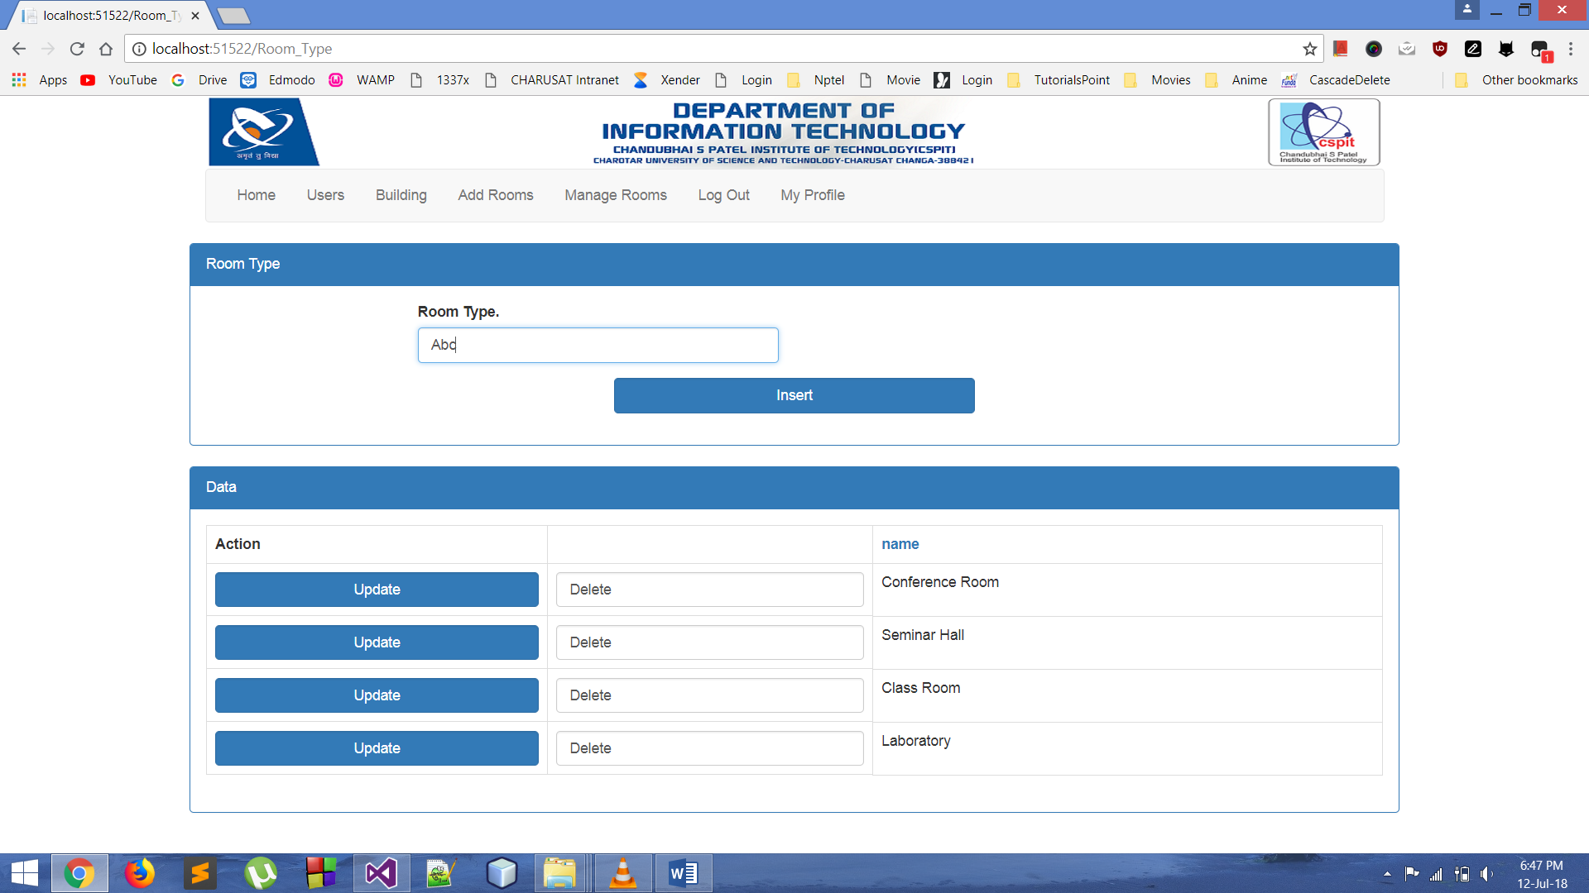

Figure 17 | Room_Type

* **Building:**

Whenever we have a new building with us and we need to add it to the records then this web form can be helpful.

**Code Snippet:**

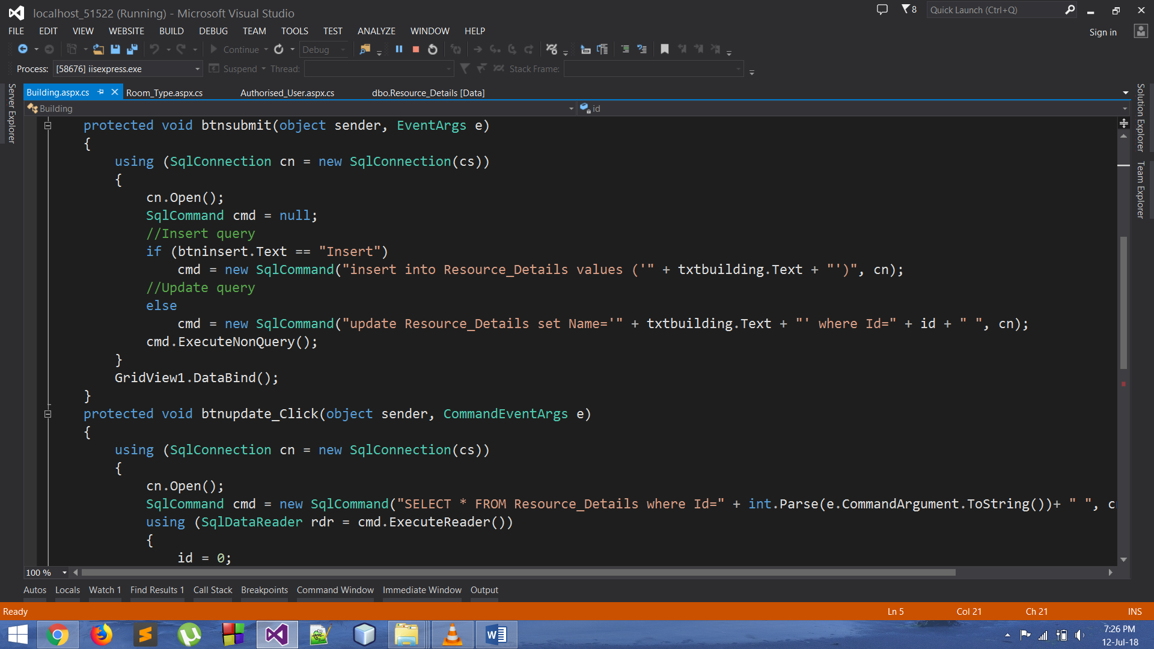

Figure 18 | Snippet Building

**Snap shot:**

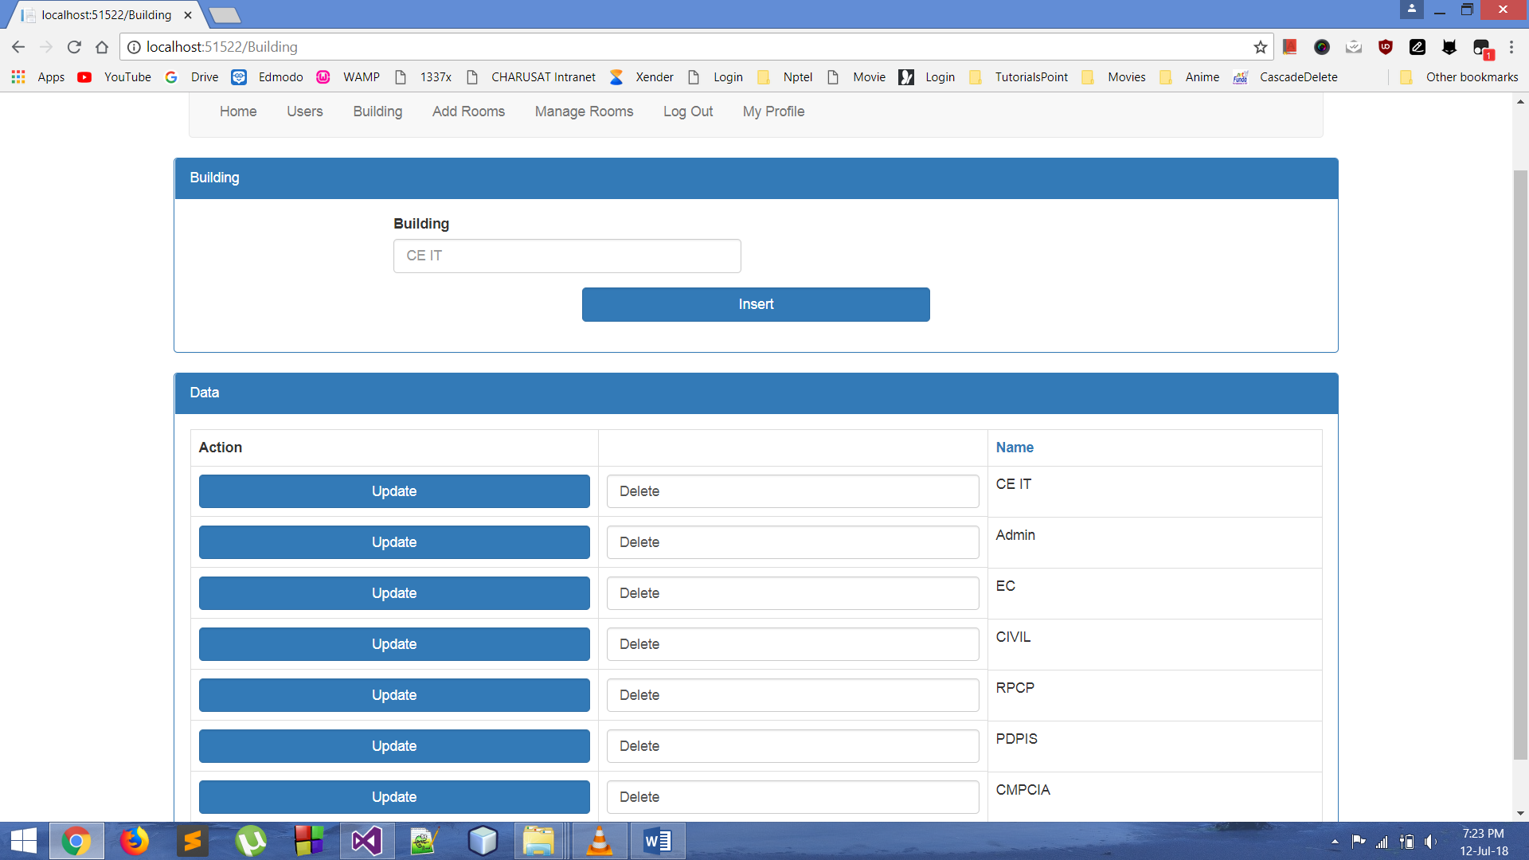

Figure 19 | Building

* **Rooms:**

Whenever new rooms are to be inserted to records then this web form comes in handy.

**Code Snippet:**

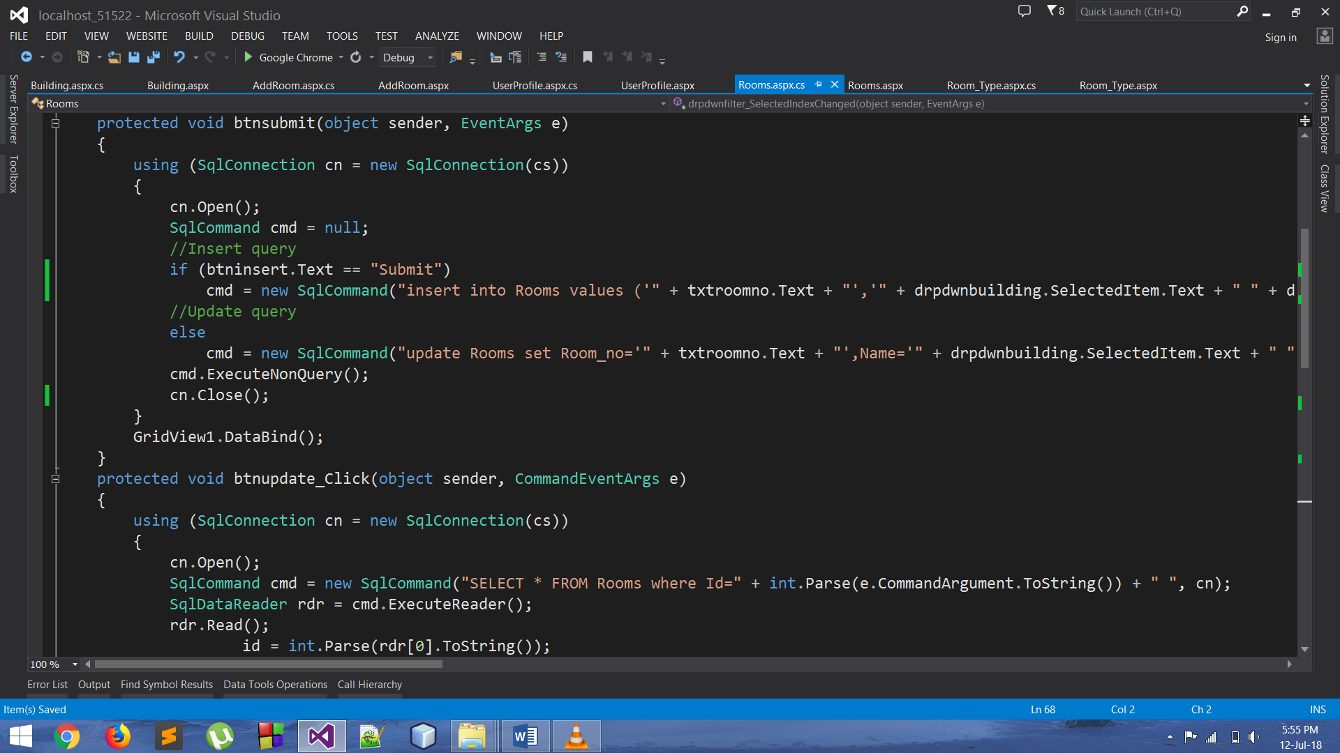

Figure 20 | Snippet Rooms

**Snap shot:**

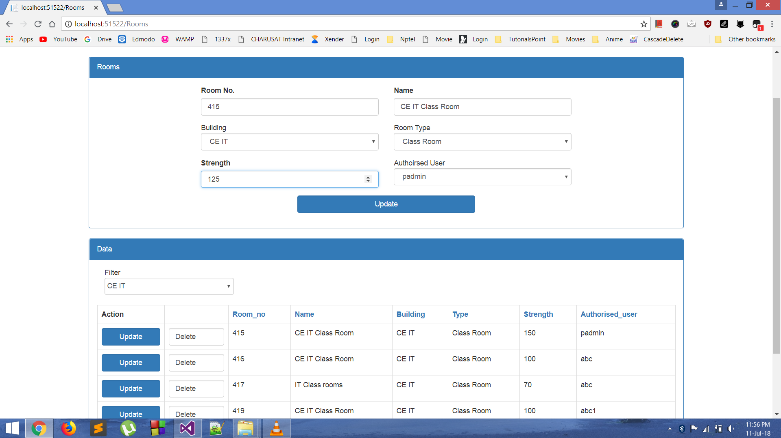

Figure 21 | Rooms

Below is the figure after the data being updated.

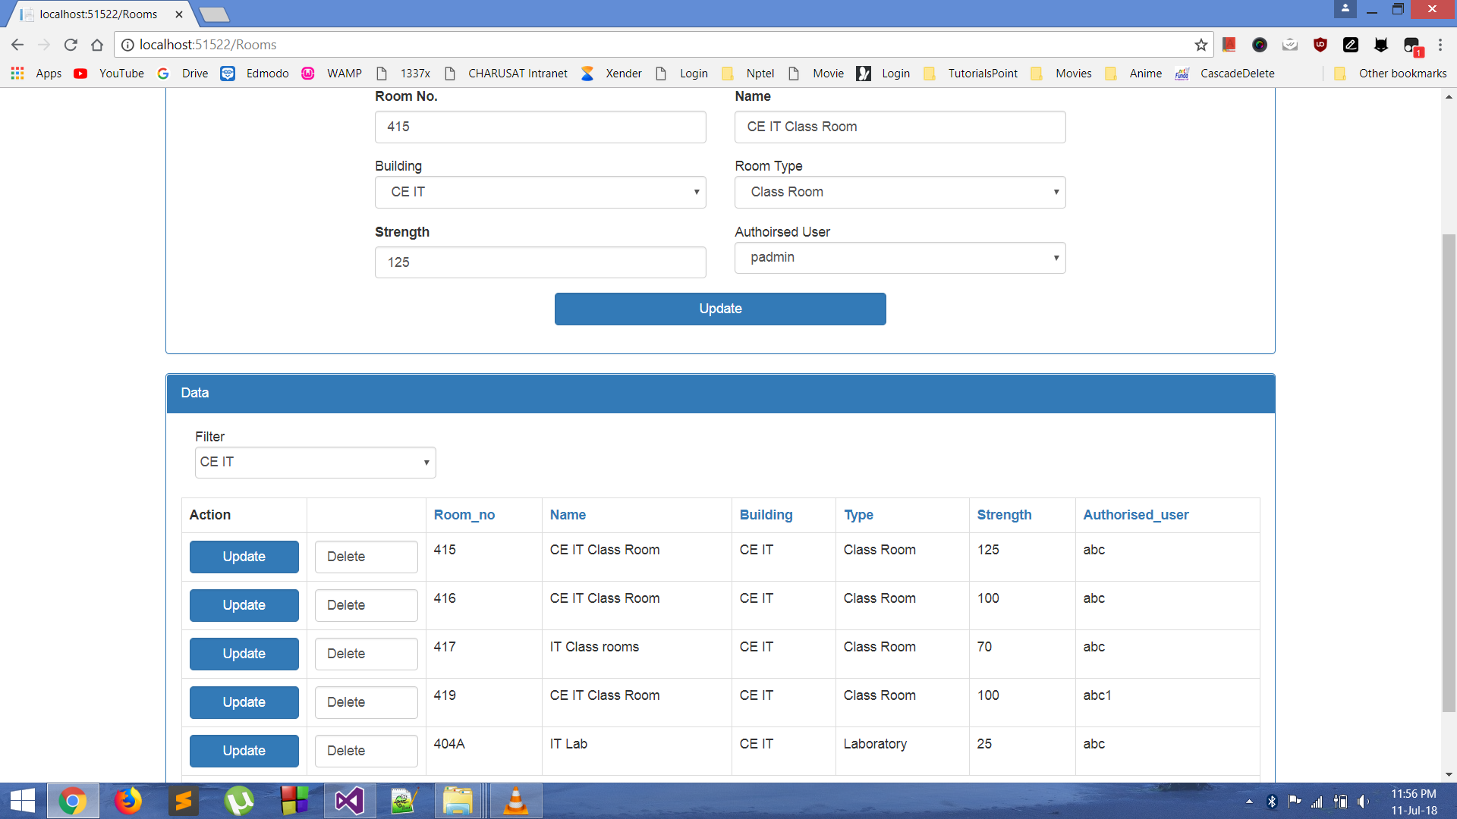

Figure 22 | Rooms(Updated)

* **AddRooms:**

Whenever there are new rooms to be added, this can be done from this web form. In this the master user has to add all the specified and required details of the rooms like Room number, Room type, Building, Strength, Authorised user etc. If the user feels the requirement to add one of these fields like Authorised User, Room Type, Building etc. then they are not supposed to switch to other web form. Because this web form has all that functionalities.

**Code Snippet:**

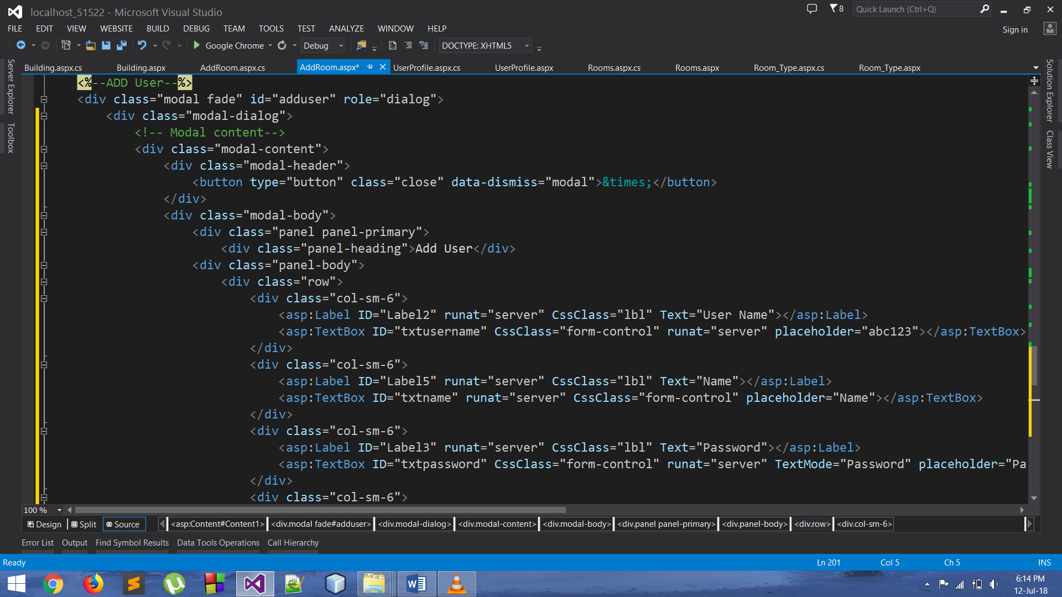

Figure 23 | Snippet AddRooms

**Snap shot:**

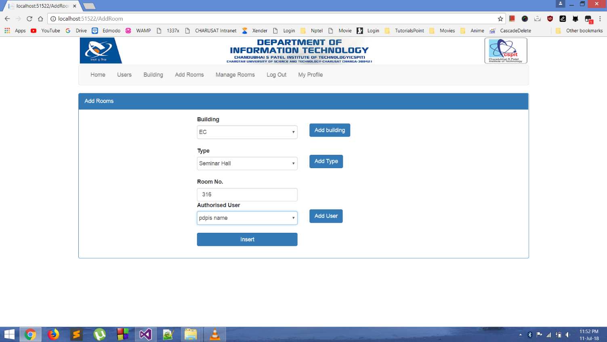

Figure 24 | AddRooms

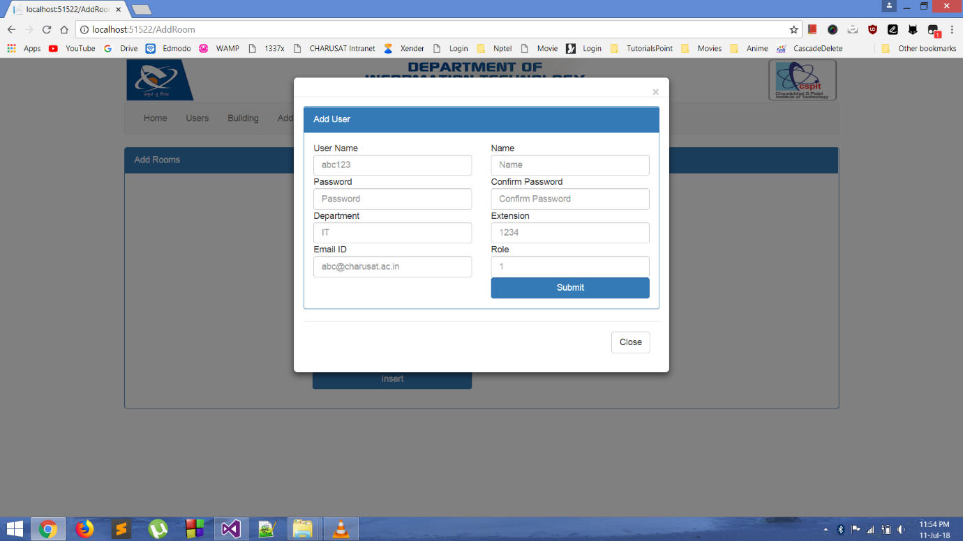

Figure 25 | AddRooms(User Pop up)

* **Forgot Password:**

If the authorised user by any chance forges the password, then this web form comes into the role. The user just simply has to enter his username and registered email id. After the verification of the registered username and the email id in database the user gets the message that the password has been mailed to the user. So he can use his email id and fetch the password from there. This thing comes in handy a very few times.

**Code Snippet:**

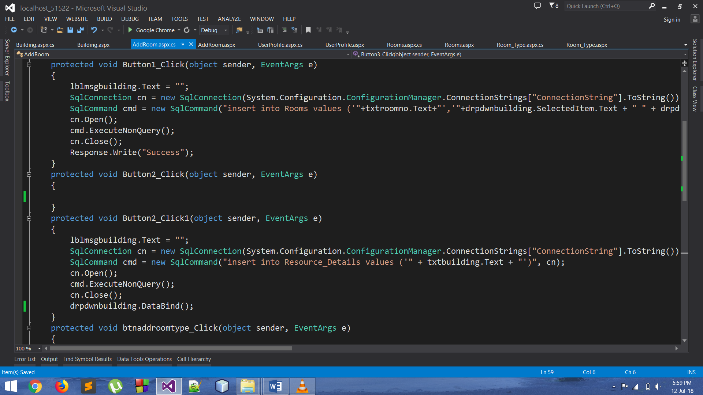

Figure 26 | Snippet Forgot_Password

**Snap shot:**

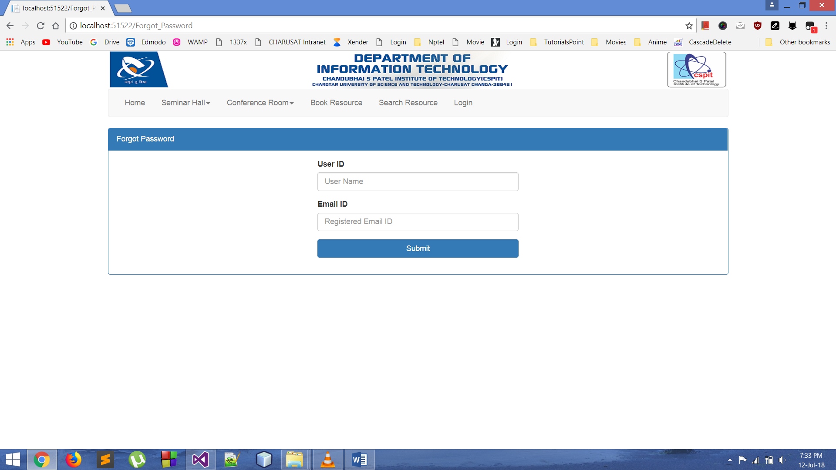

Figure 27 | Forgot_Password

* **Sending E-mails:**

While the process is still carried out manually the user is always supposed to write the mail in order to request for the resource. And also the master user needs to notify if the request was granted or rejected.

So all this can be done through the system generated mail. Which reduces our manual work to zero. In this project the mail service is used for requesting resource, and also to notify the user about the status of his request i.e. whether granted or rejected.

**Code Snippet:**

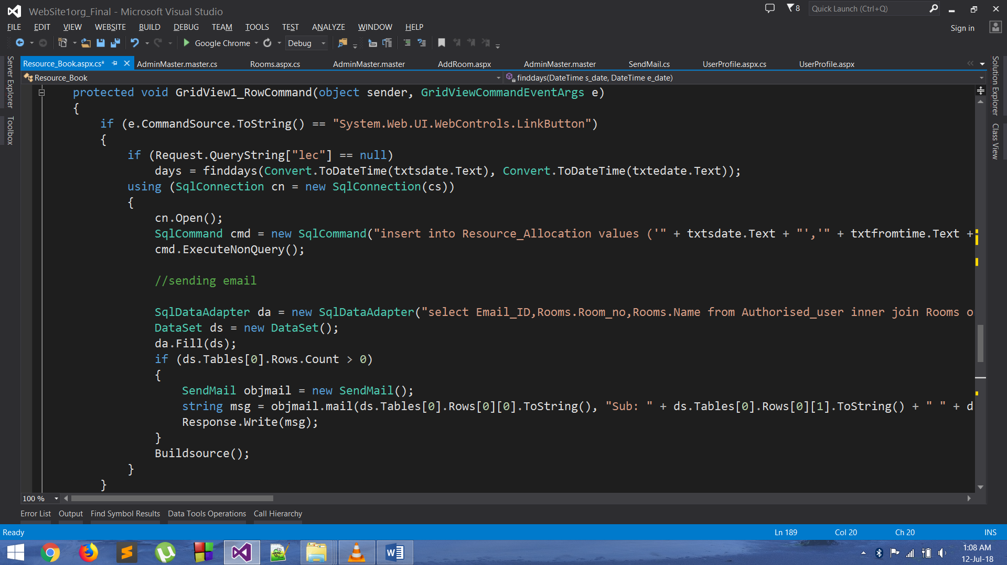

Figure 28 | Snippet Sending Mails

**8.DESIGN**

* **Database design:**

Here we have created the database tables. Various tables for their various intended requirements. The main tables are:

* Resource_Allocation
* Rooms
* Authorised_User
* Room_Type
* Resource Details, etc.

The columns were added, modified, removed etc. after they were created as per the need arises. The foreign key primary key constraints were added to columns as per the requirements.

* **Page Design:**

The page design mainly includes creating the master page and adding CSS properties in various web forms as per the requirements. The master page design includes the header and the navigation bar as per the authorised user. Then it contains the form for user inputs and the Data section for all the data which is collected from the user inputs.

For making this application responsive and also for few designing purposes we have added the Bootstrap into our web forms. Modal pop ups and many other things are added using BootStrap

**Code Snippet:**

.

Figure 29 | BootStrap(Modal Popup User)

**9.CONCLUSION**

This project meant a new experience for me as I have learned so many new things in the field of Web site designing to meet few of the real time requirements of the project. This summer internship programme provided me with the opportunity to invest my precious time in learning some of the new technologies like ASP.NET, ADO.NET, C#, BootStrap etc. and working with them. I got to experience something new, as all this the things were totally different from whatever I just learned through the books theoretically but I got the first-hand experience to implement all this knowledge I gained in some of the real time project. It also lets us learn some new things which I just can’t learn from books without experiencing them myself while going through the hard times in the project. The internship programme now let me have a bit clear idea of how the things work out in real apart from the theories that we always go through. So, I got to learn many new things and had a great experience creating something totally different from what I was used to.

**10.FUTURE WORKS**

Almost all the required functionalities are added in this application. Now for making this application more optimized we are planning to add few of the properties and concepts like Stored procedures, caching etc. We may now further focus and make some changes on the frontend too. We were thinking to make some kind of notifications that may display some important things. Or maybe notifications just pops up whenever the user logins.

**REFERENCES**

1.) C# Kudvenkat

<https://www.youtube.com/watch?v=SXmVym6L8dw&list=PLAC325451207E3105>

2.) ADO.NET Kudvenkat

<https://www.youtube.com/watch?v=aoFDyt8oG0k&list=PL6n9fhu94yhX5dzHunAI2t4kE0kOuv4D7>

3.) ASP.NET Kudvenkat

<https://www.youtube.com/watch?v=3AYoipyqOkQ&list=PL6n9fhu94yhXQS_p1iHLIftB9Y7Vnxlo>

1. <https://getbootstrap.com/>
2. <https://www.w3schools.com/bootstrap/default.asp>